Team 03 – Task Minder App

# Team Contact Information

|  |  |  |  |
| --- | --- | --- | --- |
| Project Manager | Ryan Dockstader | (435) 799-7237 | ryanldockstader@gmail.com |
| API Integration | Cameron Dockstader | (208) 842-6654 | d@camd.me |
| Operating Officer | Jason Halverson | (702) 338-8995 | halv.jason@gmail.com |
| Software Architect | Kevin Billings | (469) 5252-6994 | ktbillings@gmail.com |

# An Overview of the Problem

Tasks often get forgotten, especially ones that need to be checked every x amount of time. Tasks such as laundry, the dishes, vacuuming, and other household chores fall easily into this category. Something that could remind you at a set time, and then repeat that reminder after every x minutes/hours/etc. would be very helpful in helping busy people remember to get the little things done each day.

# Core features and stretch goals from your requirements document

## Required Features

* User login
* add tasks for users
* Tasks will have a set type (laundry, dishes, etc.)
* Tasks can be reoccurring

## Stretch Goals

* You can assign users to user groups
* You can assign tasks to other users in your user groups
* import/export tasks to/from a CSV file
* SUPER STRETCH: API integration (such as with Canvas, Google Calendar, etc.)

# An Overview of the design / approach

A scheduler app. It lets you put in tasks that are repeated weekly, monthly, etc. and then give details about that task when it's time to do them. I.E. you could schedule laundry each week for Wednesday at 10 am and on the first reminder it would prompt for how many loads you're doing and then would prompt you every hour to start a new load.

Major Components:

* User sign up/login for task tracking
* Task Scheduler to set alert reminders.
* An API to span multiple devices
* Add task interface
* Manage task interface for things happening today, or via a calendar

# UML

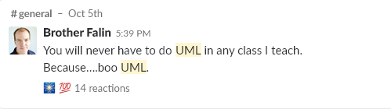

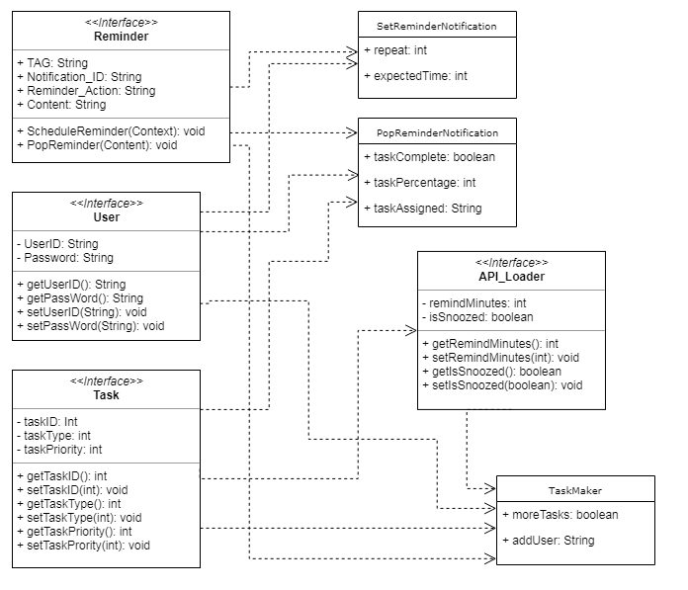

# User Interface Plans

